Lab Report on the Ti:Sapphire dataset acquired on 2025-06-04 (yyyy-mm-dd)

According to the comparison between the two different Start Stop measurements from Hanbury-Brown-Twiss experiment, we can safely conclude that the still unknown peaks that I’m seeing are not caused by some misbehavior inside of the SNSPD, since they are perfectly skew symmetric upon sending

t🡪(-t)

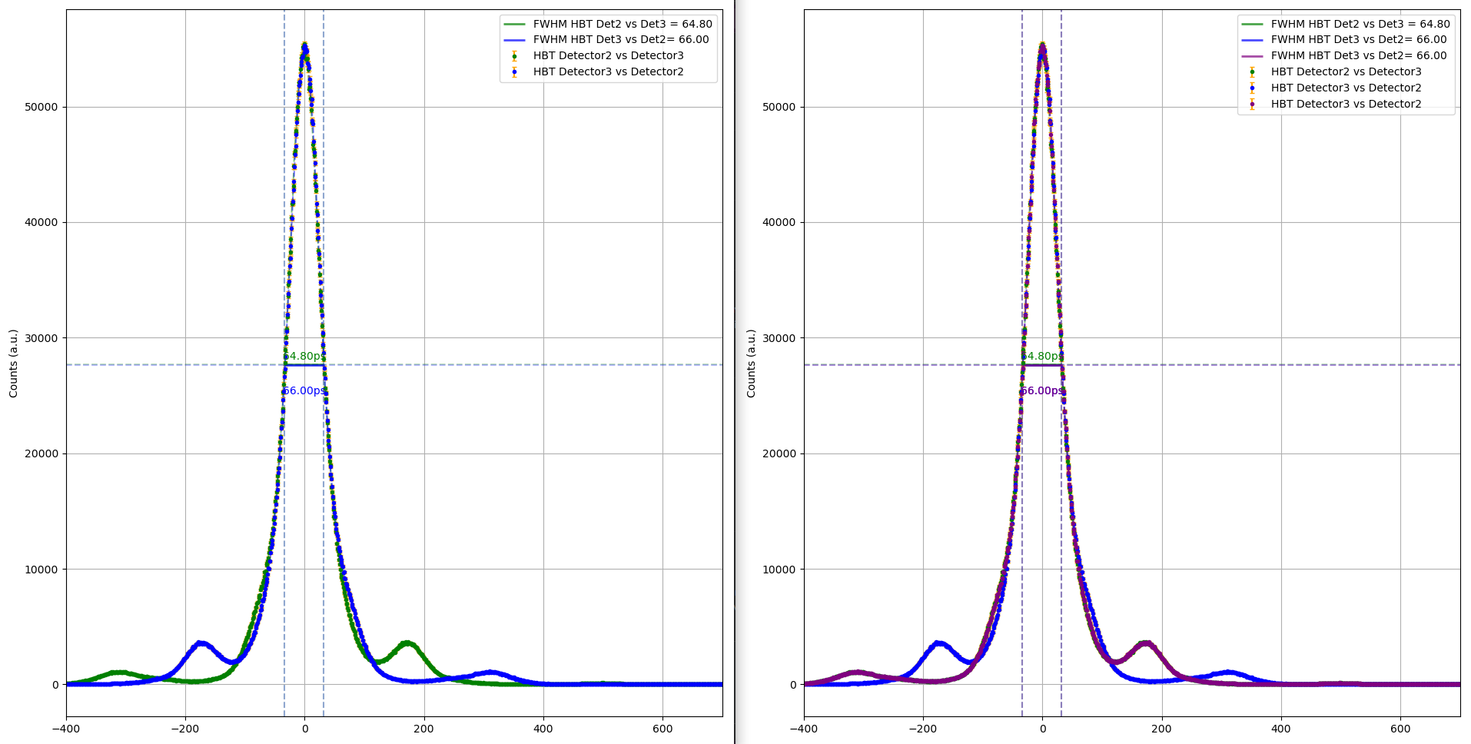

~-177ps

~177ps

Evidence in support of this statement comes directly from the comparison between the two different Start-Stop Measurements : the purple line, corresponding to the blue line time reversed exactly tracks the green plot !!!!

2) Shift between FWHM of the HBT’s main peaks is exactly half of the shift that I see comparing TCSPC’s FWHMs (1.2ps compared to 2.4ps EXACTLY)

Normalized plots to give more infos about this ? (How can I perform such normalization ?)